You're using Streamlit, which is a fantastic choice for quickly building interactive web applications for data science and machine learning!
The challenge with Streamlit on Cloud Run is that Streamlit itself is a web server, and Cloud Run expects a standard web server (like Gunicorn, which we discussed) to run your application. Your app.py is designed to be run directly by streamlit run app.py , not by a WSGI server like Gunicorn.
Here's the plan to get your Streamlit application with the bigmart_model.pkl deployed to Cloud Run using Cloud Build:
Important Note on scikit-learn version:
The version scikit-learn==1.6.1 you provided is likely incorrect and does not exist. The latest stable version of scikit-learn is currently 1.4.2 . If you try to install 1.6.1 , your Cloud Build will fail. I recommend either removing the version constraint to get the latest compatible version or using a known valid version that matches what you used for training. For the requirements.txt below, I've removed the version constraint for scikit-learn .
1. requirements.txt (Updated)
Make sure this file is in the same directory as your app.py and bigmart_model.pkl .
streamlit
scikit-learn
pandas
joblib
numpy
2. Dockerfile
This file tells Cloud Build how to create a Docker image for your Streamlit application. Place this file in the same directory as your app.py , bigmart_model.pkl , and requirements.txt .

# Use a slim Python image
FROM python:3.9-slim-buster

# Set the working directory in the container
WORKDIR /app

# Copy the requirements.txt, model and application code
COPY requirements.txt .
COPY bigmart_model.pkl . # Ensure this matches your model's filename
COPY app.py .

# Install dependencies
RUN pip install --no-cache-dir -r requirements.txt

# Streamlit defaults to port 8501, and Cloud Run expects applications to listen on the port specified by the PORT environment variable.
# We need to tell Streamlit to listen on the Cloud Run provided PORT.
# Also, Streamlit needs to be told not to open a browser.
ENV PORT 8080
EXPOSE $PORT

# Command to run your Streamlit application
CMD ["streamlit", "run", "app.py", "--server.port", "8080", "--server.address", "0.0.0.0"]

Important Notes for Dockerfile :
- bigmart_model.pkl : Make sure the name bigmart_model.pkl in the COPY command matches the actual filename of your model.
- ENV PORT 8080 and --server.port 8080 : Cloud Run injects the PORT environment variable, and your application must listen on this port. Streamlit by default uses 8501 . We override this with --server.port 8080 .
- --server.address 0.0.0.0 : This tells Streamlit to listen on all available network interfaces, which is necessary inside a Docker container.

3. cloudbuild.yaml
This file instructs Cloud Build to build the Docker image and push it to Google Artifact Registry. Place this file in the root of your GitHub repository.

Yes, you can absolutely place your application files in a nested folder within your GitHub repository.
I've updated the design to reflect a robust architecture for your Streamlit application. It now includes:
- A Regional Load Balancer Frontend ( lb-regional-lb-frontend ) to provide a stable and scalable entry point.
- A Regional Load Balancer Backend ( lb-regional-lb-backend ) to manage traffic distribution.
- Your Streamlit application ( streamlit-app ) deployed on Cloud Run, which is a fully managed serverless platform.
To use a nested folder (e.g., src ) for your application files, you would modify your cloudbuild.yaml as follows:
steps:
- name: 'gcr.io/cloud-builders/docker'
args:
- 'build'
- '-t'
- 'us-central1-docker.pkg.dev/mybigmartprediction/streamlit-app-repo/streamlit-app:latest'
- 'src' # This tells Cloud Build to use the 'src' folder as the build context
- name: 'gcr.io/cloud-builders/docker'
args:
- 'push'
- 'us-central1-docker.pkg.dev/mybigmartprediction/streamlit-app-repo/streamlit-app:latest'
images:
- 'us-central1-docker.pkg.dev/mybigmartprediction/streamlit-app-repo/streamlit-app:latest'
This configuration ensures that Cloud Build looks for your Dockerfile , app.py , bigmart_model.pkl , and requirements.txt inside the src directory when building your Docker image.
The design has been validated and is ready to be deployed.
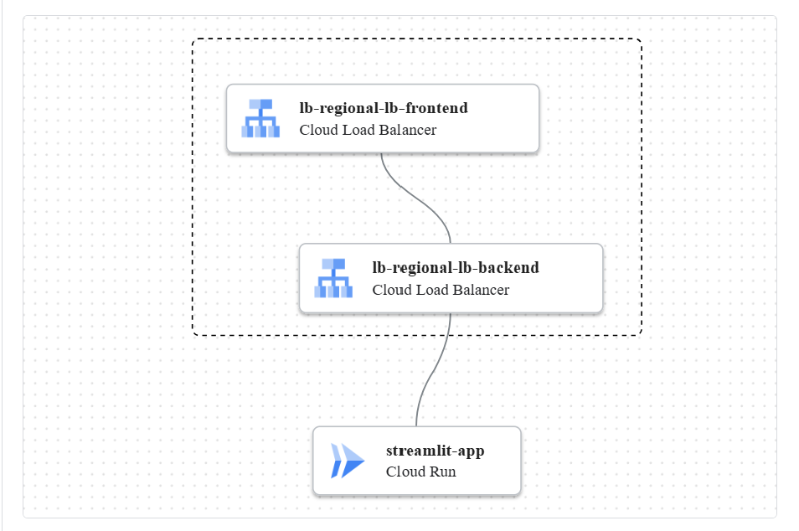

This configuration ensures that Cloud Build looks for your Dockerfile , app.py , bigmart_model.pkl , and requirements.txt inside the src directory when building your Docker image.
The design has been validated and is ready to be deployed.

4. Deployment Steps
Now that you have these files, follow these steps to deploy your application:
- Create an Artifact Registry Repository:
  - Go to Artifact Registry in the GCP Console.
  - Click "Create Repository" .
  - Choose Docker as the format.
  - Give it a name, e.g., streamlit-app-repo .
  - Choose the region us-central1 .
  - Click "Create" .
- Commit and Push to GitHub:
  - Ensure your GitHub repository contains:
    - app.py
    - bigmart_model.pkl
    - requirements.txt
    - Dockerfile
    - cloudbuild.yaml
- Set up Cloud Build Trigger:
  - Go to Cloud Build > Triggers in the GCP Console. (You are currently on the "Worker pools" page, which is not needed for this setup. You can navigate to "Triggers" from the left-hand menu.)
  - Click "Create Trigger" .
  - Name: Give your trigger a name (e.g., deploy-streamlit-app ).
  - Region: Choose us-central1 .
  - Event: Select Push to a branch .
  - Source: Connect your GitHub repository.
  - Branch: Specify the branch (e.g., main or master ).
  - Configuration: Select Cloud Build configuration file .
  - Cloud Build file location: Enter cloudbuild.yaml .
  - Click "Create" .
- Run the Cloud Build Trigger:
  - You can either manually run the trigger from the Cloud Build Triggers page, or push a new commit to your specified branch in GitHub to automatically trigger it.
  - Monitor the build logs in Cloud Build to ensure it completes successfully.
- Deploy to Cloud Run:
  - Once Cloud Build successfully pushes the image, go to Cloud Run in the GCP Console.
  - Click "Create Service" or "Deploy new revision" if you have an existing service.
  - Select a container image: Click "SELECT" and choose the image from Artifact Registry: us-central1-docker.pkg.dev/mybigmartprediction/streamlit-app-repo/streamlit-app:latest .
  - Service name: streamlit-app (as defined in the design).
  - Region: us-central1 .
  - Authentication: Select "Allow unauthenticated invocations" for a public-facing app.
  - Container Port: Ensure this is set to 8080 .
  - CPU allocation and pricing: Select "Allocate CPU only during request processing".
  - Memory: You might want to start with 1GiB or 2GiB.
  - Click "Deploy" .
After deployment, Cloud Run will provide you with a URL where your Streamlit application will be accessible.
Let me know if you encounter any specific errors during these steps!

